**1.Elastic public IP allocation**

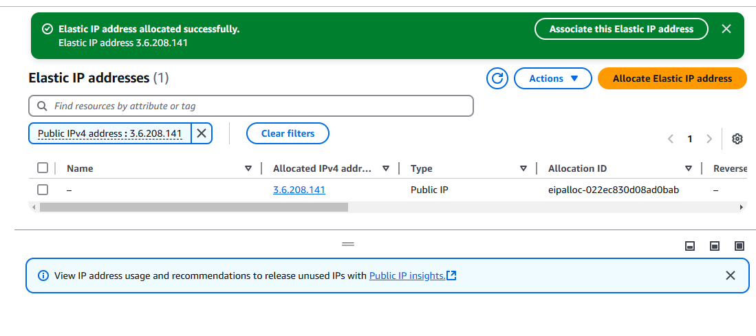

2.**Before EIP allocation Public IP of Instance**

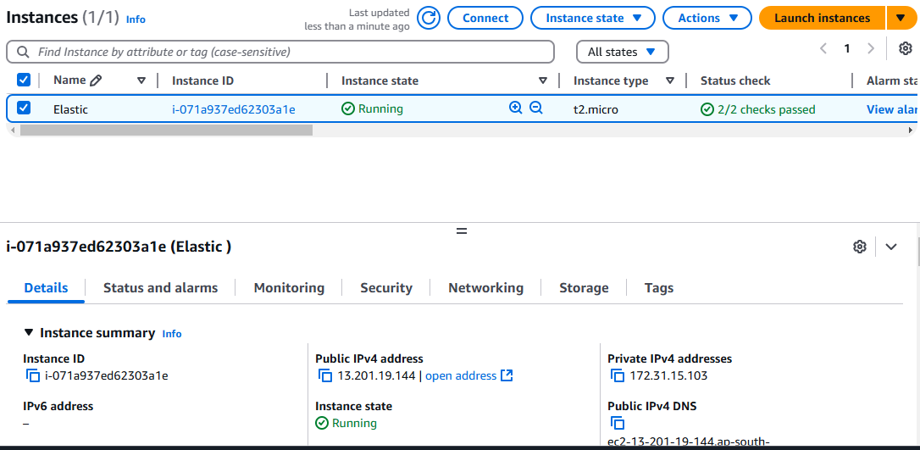

3. **Association of EIP**

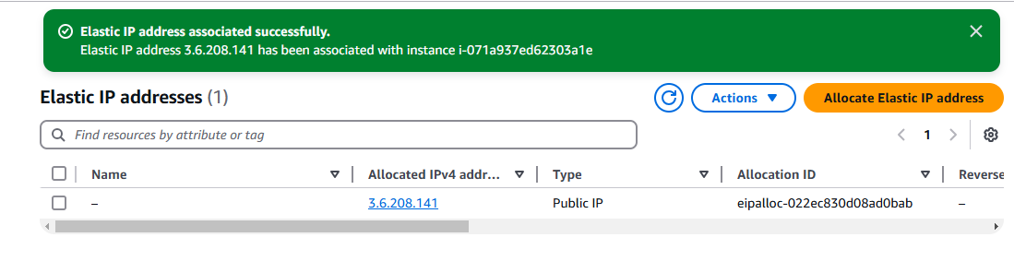

**4.Public IP of instance Post to association of EIP to the instance**

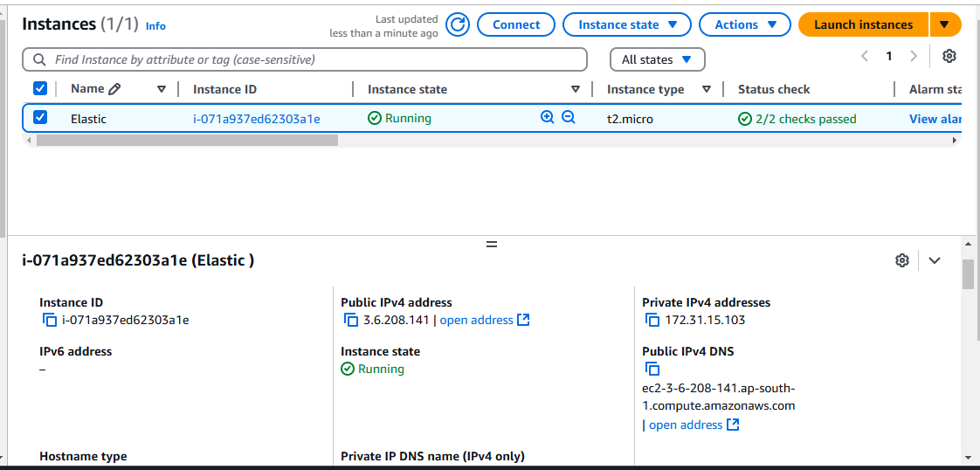

**5. Tried to stop the instance and observed still the public IP remains unchanged, Hence EIP has been allocated to the server successfully**

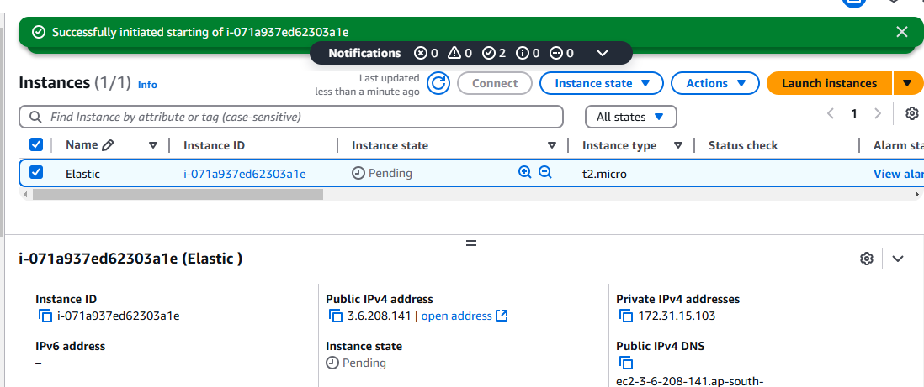

**6. Terminated server and EIP released back to AWS account**

